# JAVA setup

## Java 8

Starting point for downloads: <http://www.oracle.com/technetwork/java/javase/downloads/index.html>

Pick the JDK (Java Development Kit), and preferably the 64bit version and download it.

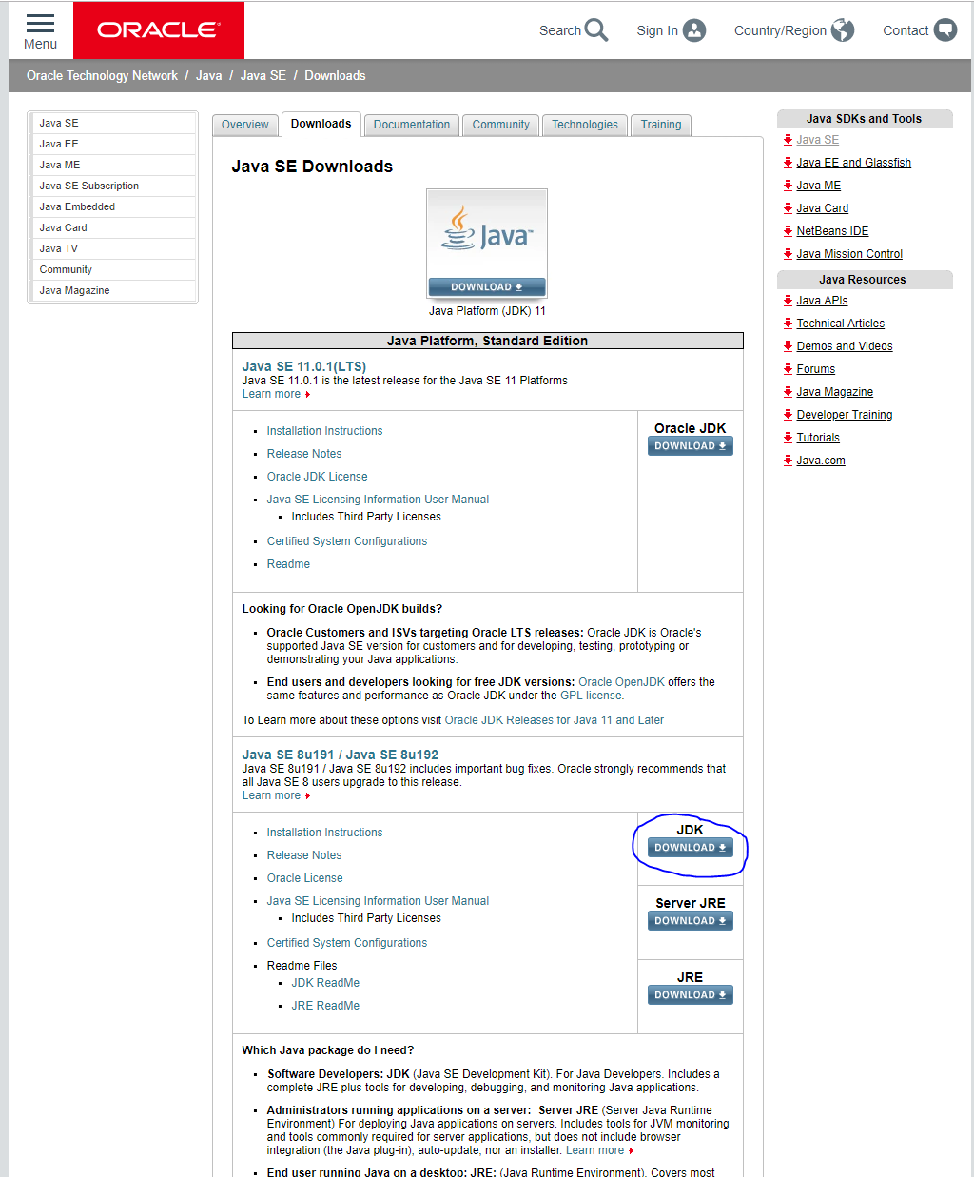

### 

### Installation of Java

Run the installer, and accept the default suggestions.